New Heights Dance Theater

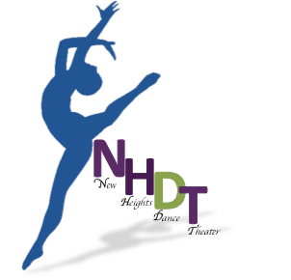
Jennifer Stimson, President
Brian Ervay, Vice President
Eliene Putnam, Secretary
Len Salvatore, Treasurer
Leslie Updyke, Artistic Director
251 East 14th Street
New Heights Dance Theater
2020 Legends! - Dancer’s/Parent’s Agreement

Please read, sign and return this agreement to NHDT on your first day of rehearsal. If you are under 18 years of age, a parent or legal guardian signature is also required.

I, accept all parts that have been awarded to me for the 2020 Legends! A Tribute to the Music of Lady Gaga and Queen.

I agree to become a member of New Heights Dance Theater and pay all fees as it relates to this production.

I understand it is my responsibility to be enrolled in and attending a weekly ballet class and if I have a specialty part, to be enrolled and attending a weekly pointe, lyrical, jazz and/or acro class to maintain and improve my skills. This information will be verified.

I understand I am required to dress appropriately for all rehearsals. Female dancers: black leotard preferred (solid colors accepted-no patterns), clean tights and hair in a bun. Dance skirts or shorts are permitted. Male Dancers: white or black shirt (no writing on the shirt) and dance/sport shorts or pants. Please keep jewelry to a minimum and NO BAGGY CLOTHES ALLOWED WHILE DANCING.

I agree to attend winter and spring rehearsals, dress rehearsals and performances. I understand that participation in special events is recommended, but not mandatory.

I am responsible for learning all chorography related to my parts. If I am absent, I am responsible for contacting and working with the understudy (and/or other cast members) to review & learn any new choreography prior to the next rehearsal. I have read and understand the 2019-2020 NHDT Absentee Policy.

I understand NHDT will supply all costumes, accessories and props for all performances. It is my responsibility to have new/excellent condition tights and shoes for all performances.

I grant permission to be photographed, videotaped and/or interviewed for promotional purposes.

By signing this agreement, you agree to the above and release NHDT from any and all medical liability as it relates to the dancer listed on this form.

DANCER PARENT/GUARDIAN

Resident Dance Company with Clemens Center -Elmira New York
Elmira Heights, New York 14903
Phone: 607•737•9014
nhdtheater@gmail.com
www.nhdtheater.org
Tina Ranck, Assistant Artistic Director
Brian Hatfield, Director
Amy Kick, Director
Ann LoVecchio, Director
Ann Nordman, Director
Ashley Kuehner, Director

Ash

